CASE STUDY ON

AWS CLI



**INTRODUCTION**

The **AWS Command Line Interface (AWS CLI)** is a unified tool to manage your AWS services. With just one tool to download and configure, you can control multiple AWS services from the command line and automate them through scripts.

The AWS CLI v2 offers several new features including improved installers, new configuration options such as AWS Single Sign-On (SSO), and various interactive features.

How it works?

AWS is a secure cloud services platform that provides developers computing power, content delivery, database storage, and other infrastructure services.

Proponents point to its speed, flexible pricing, exemplary customer service, and multiple services as benefits. The AWS CLI puts the icing on the cake by bundling control of all those services into a simple command-line interface. It cuts out the user-friendly (but time-consuming) phase of interacting with the system through the Graphical User Interface (GUI).

**HANDS ON**

**Step 1:** lets first download aws cli in your system by searching aws cli download in google search. Below link will appear and based on your OS download cli.

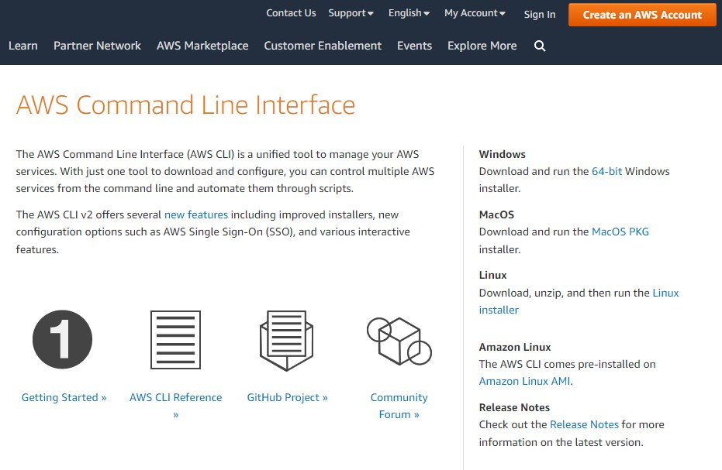

**Step 2:** In order to check whether cli has been installed or not . Open your command prompt and right the command **aws - - version**. If it show the below output the cli has been installed.

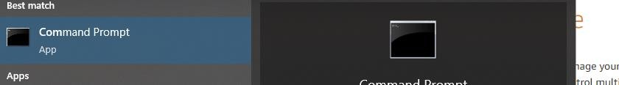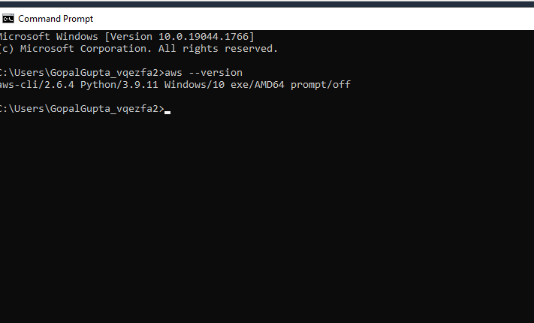

**Step 3:** In order to connect to aws using aws cli we need access keys. For that go to **security credentials** under your account. Now click on access keys then create new access keys. Note that it can be download only once so donot forget to download it

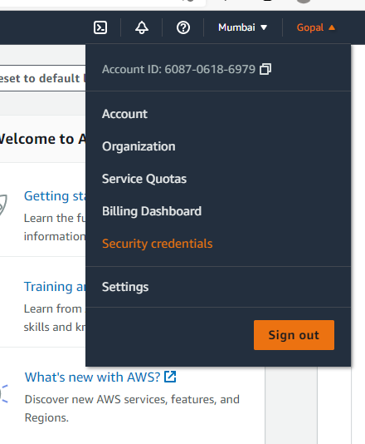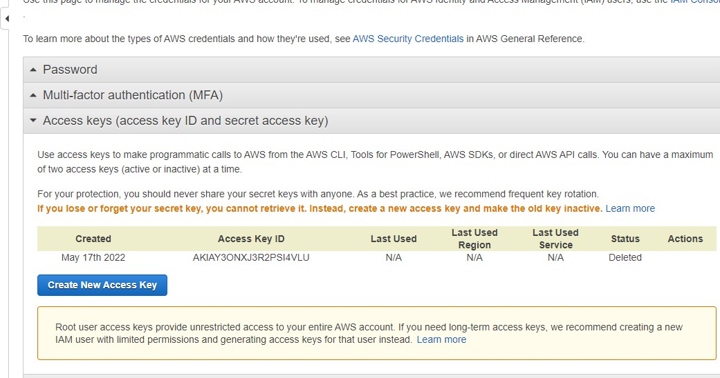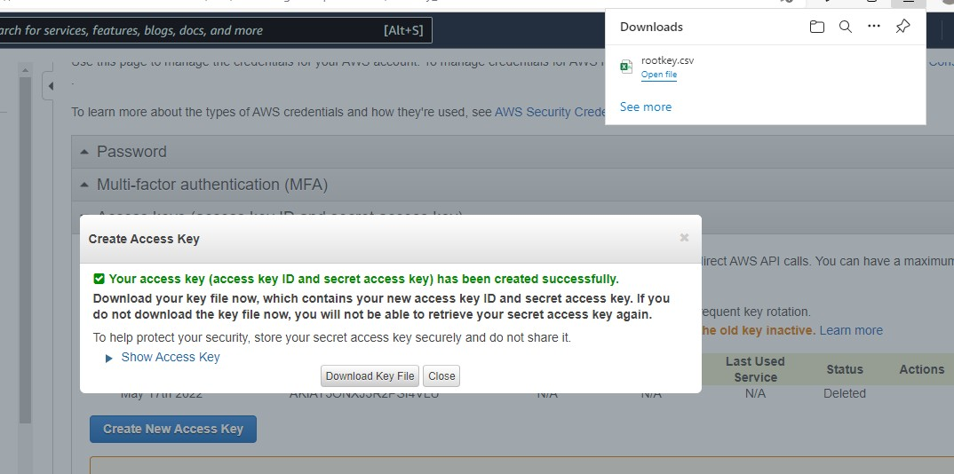

**Step 4:** Now go to command prompt and type the command **aws configure**

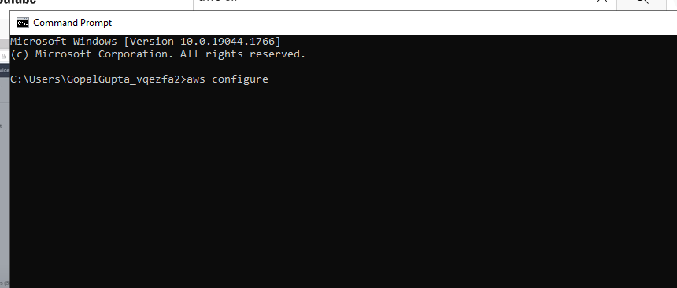

**Step 5**: It will ask **access key id ,secret access key, default**

**region** and **output format**. Give all the necessary field

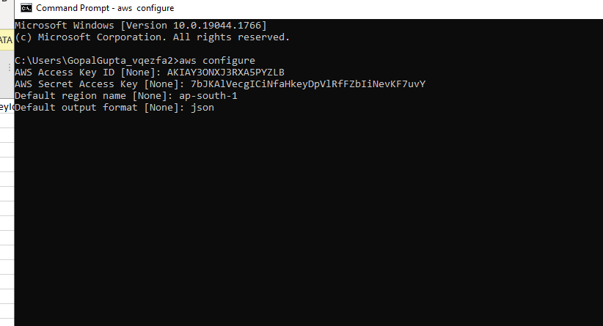

**Step 6:** lets see whether we have connected to aws or not. Let's see the list of bucket in s3 by giving command **aws s3 ls**

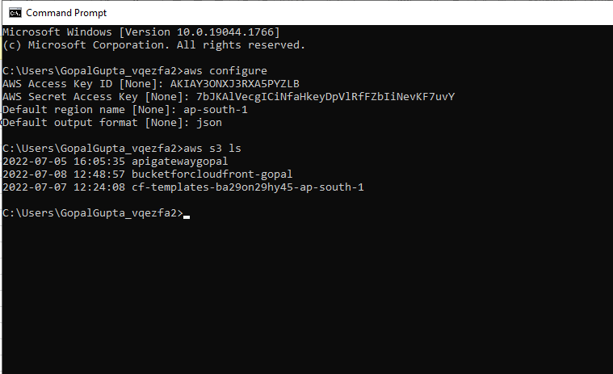

**Step 7:** Now lets create a bucket in s3 . Type the command **aws s3 mb s3://bucketname –region regionname.**

Note if the bucket name already existed then you will get the error as shown below

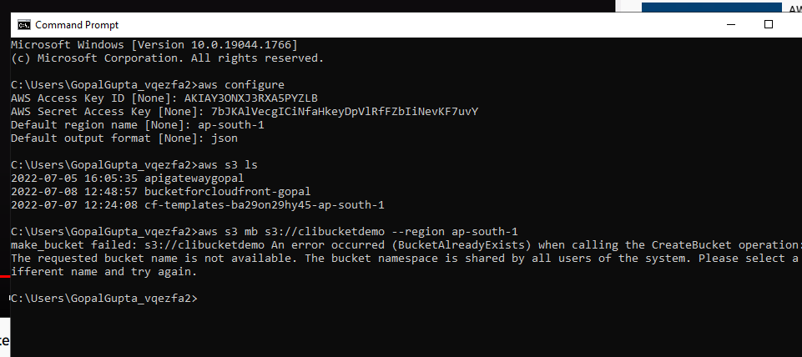

**Step 8:** Try again with the different bucket name

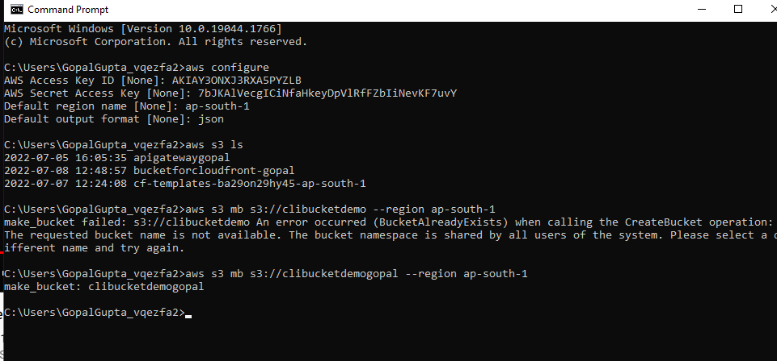

**Step 9:** Now see again the list of bucket whether our bucket has been created or not.

